Project Design Phase
Problem – Solution Fit Template

Date | 17 July 2026
Team ID
Project Name | CUSTOMER REGISTRY
Maximum Marks | 2 Marks

Problem – Solution Fit Template:
The Problem–Solution Fit identifies the challenges faced by customers and organizations in managing customer information and support requests. The Customer Registry System provides a centralized platform to register customers, manage customer records, track complaints, maintain interaction history, and improve customer service efficiency. This helps organizations reduce manual work, improve response times, and enhance customer satisfaction.
Purpose:
- To simplify customer registration and record management.
- To reduce duplicate customer records and manual paperwork.
- To improve customer complaint tracking and issue resolution.
- To provide quick access to customer information for support teams.
- To enhance customer satisfaction through efficient service management.

Template:
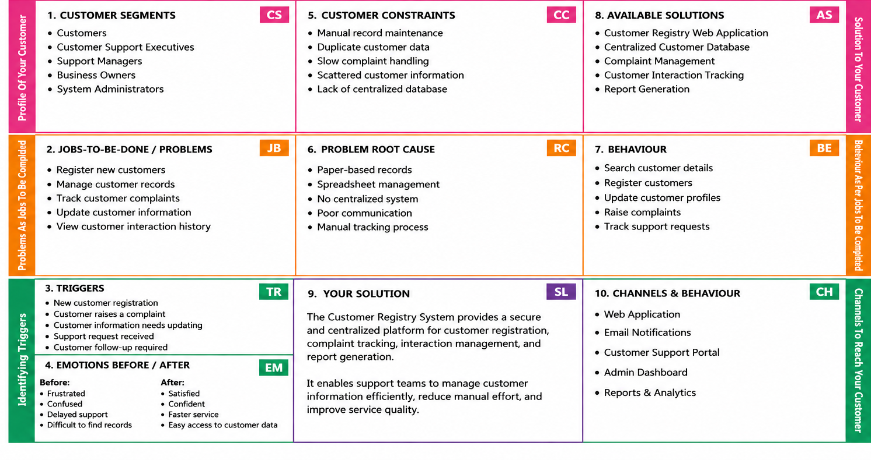
References:
- https://www.ideahackers.network/problem-solution-fit-canvas/
- https://medium.com/@epicantus/problem-solution-fit-canvas-aa3dd59cb4fe

